Project 01 – Robot Kinematics

MTRN4230 – UNSW School of Mechanical and Manufacturing Engineering

By Vinoshan Parathan

Part A: Dynamics forward kinematics

* Done via MATLAB

Part B: UR5e modelling

1. Manual calculations

(2)

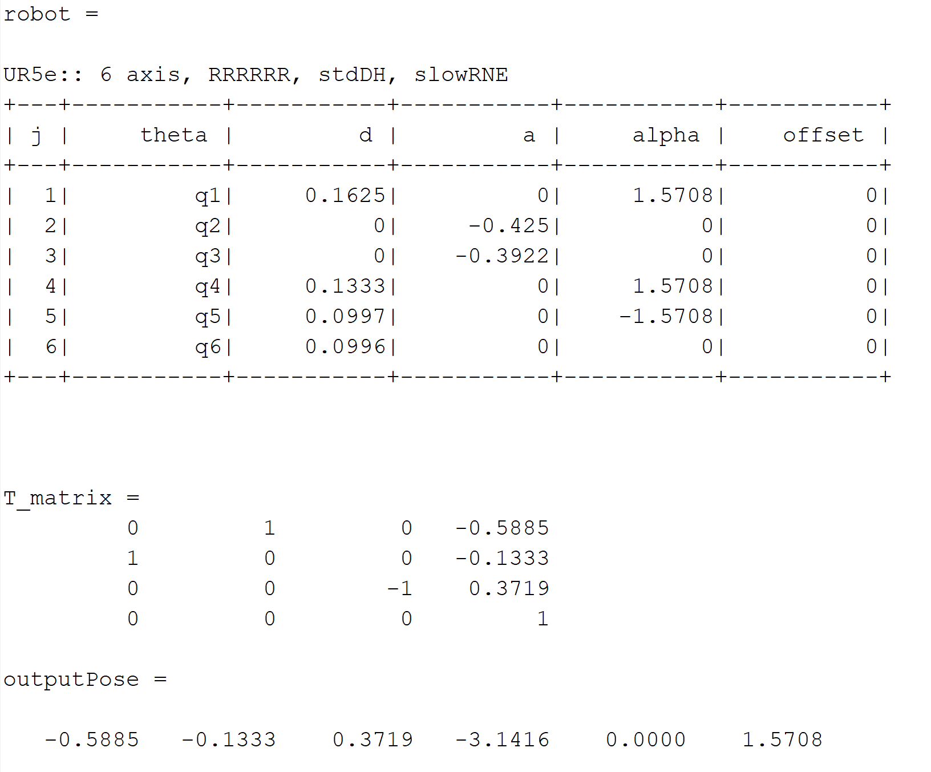

(3) 